**2021秋季学位英语期末复习 副本**

**Definition** of technical communication: Technical communication is a process of managing technical information in ways that allow people to take action.

**Purposes** of technical communication: inform, instruct and persuade.

**Unit1 User manuals and Instructions**

**Definition** of instructions: Instructions are process descriptions written to help readers perform a specific task.

1. **Basic qualities of technical communication.**

* Interactive and adaptable.
* Reader centered.
* Reliant on teamwork.
* Visual.
* Bound ethically, legally, and politically.
* International and transcultural.

1. **Writing definitions: three types of definitions.**

* Parenthetical definitions: The computers were infected by a Trojan horse (a destructive program appears to be benign).
* Sentence definitions: Hypnoanalysis is a psychoanalytical technique in which hypnosis is used to elicit information from a patient's unconscious mind.

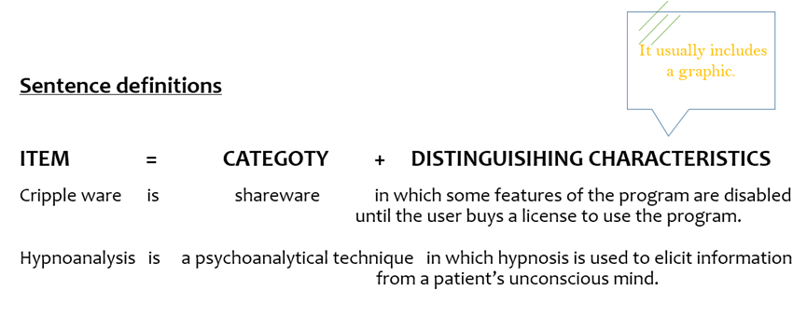

* Extended definitions: A more detailed explanation of an object, process, or idea. Usually one or more paragraphs.

1. **Guidelines for writing descriptions.**

**Mechanism and object descriptions.**

* Choose an appropriate organizational principle.
* Functional: How the item works or is used.
* Spatial: based on the physical structure of the item (e.g. from top to bottom, inside to outside, east to west, and so on).
* Use graphics.
* Photographs to show external surfaces.
* Drawings to emphasize particular items on the surface.
* Cutaways and exploded diagrams to show details beneath the surface.

**Elements contained instructions.**

* A Title (good title)
* A good title for instructions is simple and clear. Two forms are common - "How-to" and "Gerund".
* General introduction (how to draft introductions)
* The general introduction provides the preliminary information that readers will need to follow the instructions safely and easily.
* The drafting involves consideration on six aspects:
* Personnel qualified or certified to perform the task.
* Rationale (reasons) for tasks, such as changing radiator antifreeze in a car.
* Time selection for tasks such as rotating tires or planting crops.
* Safety measures.
* Items of tools, material and equipment.
* The duration of the task.
* Step-by-step instructions (tips)
* Organize the steps chronologically, in the causal order.
* Number your steps.
* Use highlighting techniques.
* Limit the information within each step.
* Include graphics.
* Use short words, short sentences and short paragraphs.
* Begin your steps with verbs.
* A Conclusion (how to draft conclusions; trobleshooting guide)

Instructions often conclude by stating that the reader has now completed the task or by describing what the reader should do next. The conclusion usually provides a troubleshooting guide or maintenance tips.

1. **Diagrammatic features.**
2. **Planning for safety.**

* Purpose
* Respect users' rights of knowing.
* Protect users' safety.
* Writing characteristics
* Clear and concise.
* Prominent and easy to read.
* Containing a reasonable amount of repetition.

Signal words are often used to indicate seriousness of the object/the procedures.

1. **Ways to improve the appearance.**

**Designing tips**

* Create an open, airy design.
* Use graphics.
* Relate graphics to text clearly.

1. **Linguistic features.**

* Use simple words and clear headings.
* Write in a friendly conversational manner.
* Use short sentences and active verbs.
* Use parallel structure.

**Unit2 Email**

1. **How communication flows in an organization.**

* Horizontal/Lateral
* Vertical
* Diagonal

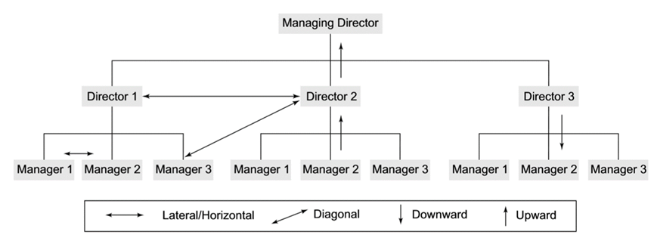

1. **Format and basic elements of an email.**

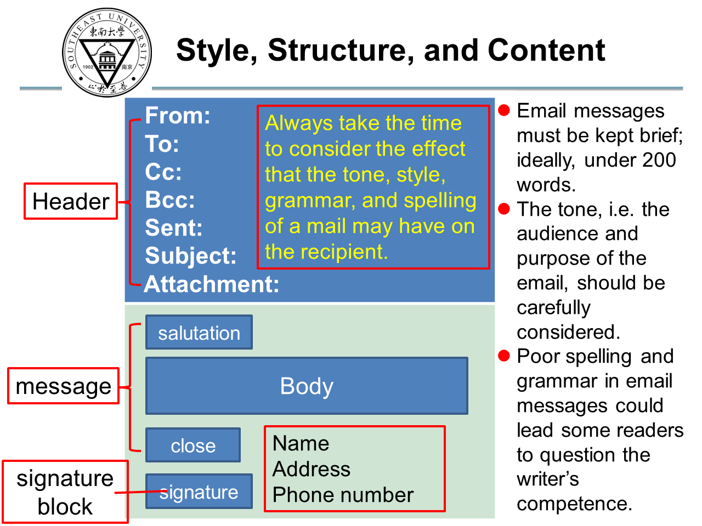

* The subject line and first paragraph clearly state the writer's purpose.
* Double-spacing between paragraphs makes the e-mail easier to read.
* The writer concludes politely.

CC = **C**ourtesy **C**opy

BCC = **B**lind **C**ourtesy **C**opy

1. **"you-attitude".**

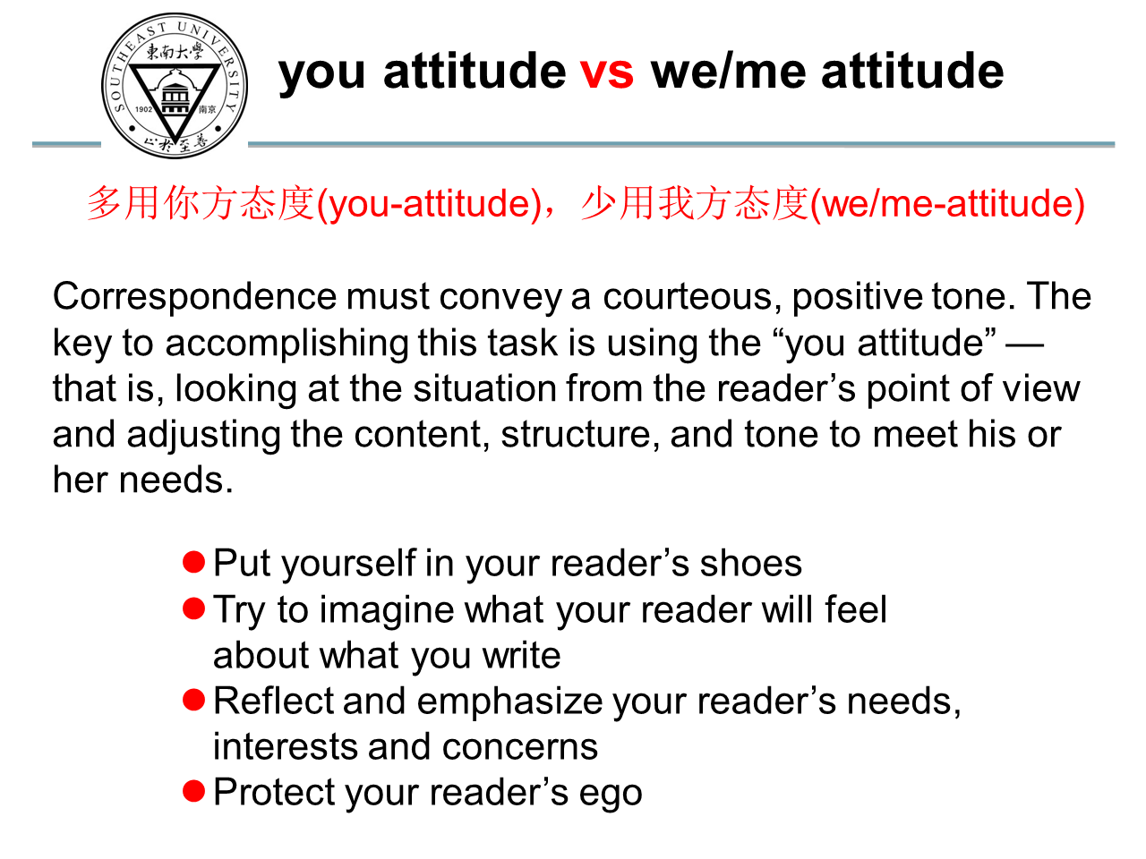

1. **Ways to improve appearance.**

↓Before↓

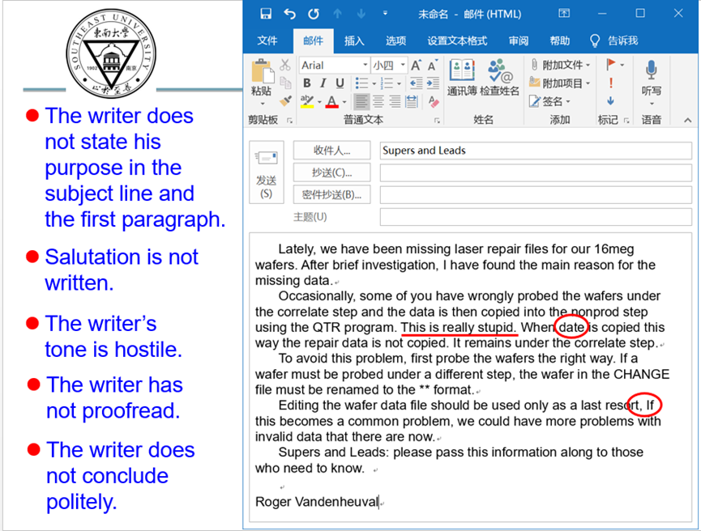

↓After↓

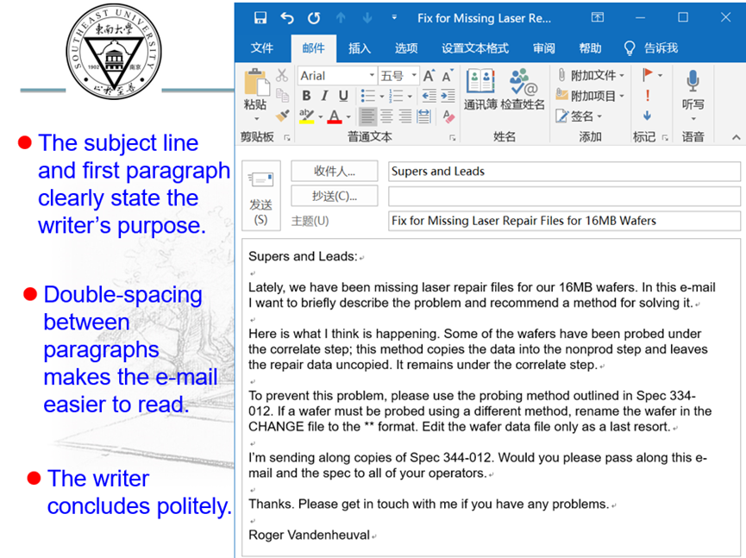

↓Before↓

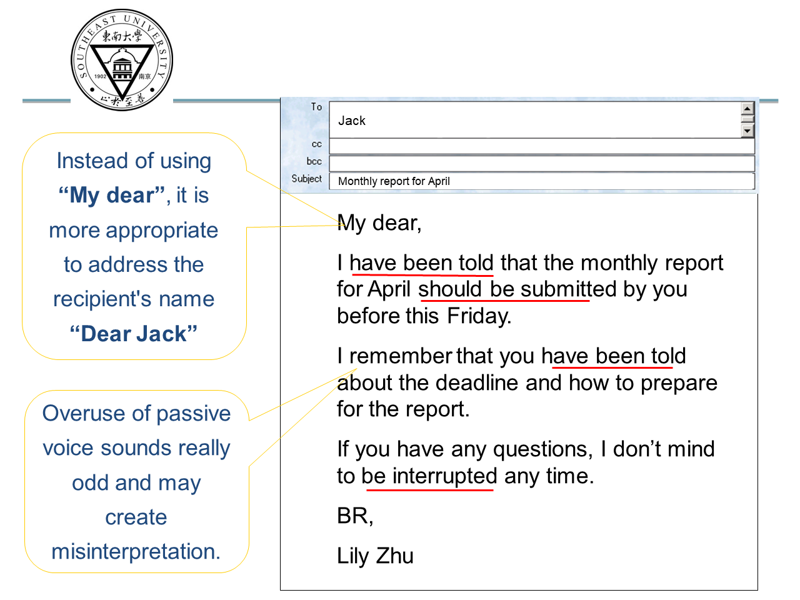

↓After↓

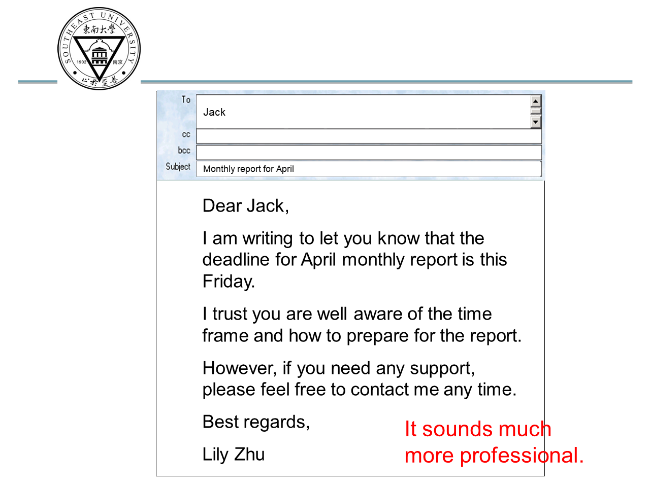

1. **Linguistic features.**

**Levels of formality.**

1. My dear father has just expired. -- formal 正式
2. My old man just kicked the bucket. -- intimate 亲密
3. My dad has died. --casual 随意
4. My beloved parent has just passed to his heavenly reward. -- frozen 庄严
5. My father has just passed away. -- consultative 商议/商榷

**Distinguish too formal and too informal styles.**

Example1: Our meeting with United went south right away when they threw a hissy fit, saying that we blew off the deadline for the progress report. (too informal)

Revision: In our meeting, the United representative expressed concern that we had missed the deadline for the progress report.

Example2: It was indubitably the case that our team was successful in presenting a proposal that was characterized by quality of the highest order. My appreciation for your industriousness is here with extended. (too formal)

Revision: I think we put together an excellent proposal. Thank you very much for your hard work.

**Unit3 Memo**

Memo: Memorandum, a written message that may be used in the workspace. Memo is an efficient way to reach people at as many levels as possible at once in an organization. A memo should start with one or two clear sentences informing the reader of the need and purpose of the communication.

The purpose of a memo is presented in 3 parts:

* The context and problem: the event, circumstance, or background of the problem being resolved or the topic handled in the memo.
* The specific assignment or task: the steps taken to help resolve the problem.
* The purpose: the reason for writing the memo and the prediction about what is in the rest of the memo.

1. **Channels of communication at workplace.**

What are the **four important channels** through which information flows within the various sections of an organization?

* Face-to-face communication.
* Communication over telephone.
* Communication through email.
* Communication through an inter-office memo.

In-person, Documents, Emails, Software, Video-conference, Phone calls, Social media.

Types: Documentary memos, Congratulatory memos, Disciplinary memos.

1. **Functions of Memos.**

* Documentation(记录存档) - expenses, incidents, accidents, problems encountered, costs, study findings, hiring, firings and reallocations of staff or equipment.
* Confirmation(确认) - a meeting agenda, date, time, and location; decision to purchase or sell
* Procedure(流程) - how to set up accounts, research on the company intranet, operate new machinery, use new software, etc.
* Recommendations, feasibility, status, inquiry and cover, etc.

1. **Audience & purposes/functions.**

**Audience**: internal.

**Purpose**: to inform, to request information, to persuade, to deliver bad news, or to confirm, etc.

**Medium**: printed or e-mail.

**Format**: an organized, concise format, usually one or two pages.

1. **Components and format of a memo.**

Key **components** of a memo:

* Memo identification lines (Subject line should be specific)
* Introduction (clear statement of purpose)
* Summary (main idea; request for meeting)
* Discussion (details about the message, background, i.e., two out of 500 models)
* Conclusion (should only consider the external drive)
* Recommendation (statement of what the reader should do next)

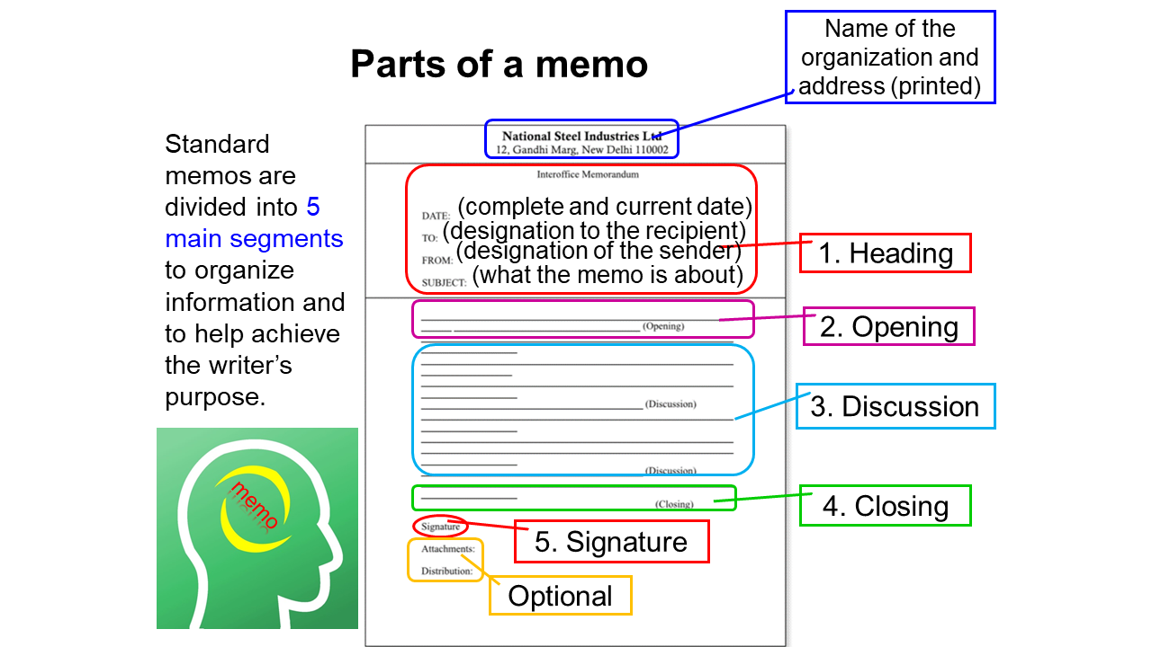

Heading, Opening, Discussion, Closing, Signature

Necessary Attachments (Optional), Distribution (Optional).

**Format**:

* The format of a memo follows the general guidelines of technical and professional writing - block format.
* Single spaced.
* Left justified (flush left)
* Skip a line between sentences to show new paragraphs (instead of using indentations).
* No indents for paragraph.
* Usually a page or two long.
* Technical and professional materials should be concise and easy to read. Therefore, it is beneficial to use headings and lists to help the readers pinpoint certain information.

1. **Writing skills.**

**Subject writing skills**

Good subjects：

* PERMISSION TO CHANGE PROCEDURE
* REQUEST FOR FOUR MACHINES
* DETAILS OF TRAINING PROGRAMME
* TERMINATION OF SERVICES
* ARRANGEMENTS FOR THE CONFERENCE

You may find that the topic and the main focus are connected by a preposition in all these examples. Such a combination works well in all subject lines and clarifies the actual subject matter of the meme to the reader.

**Closing writing skills**

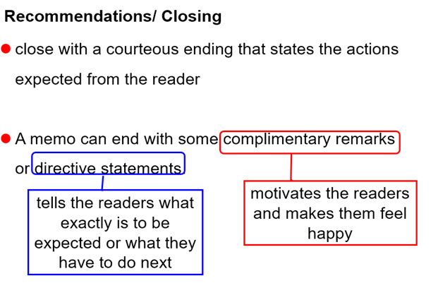

Complimentary Close Examples:

* If our results continue to improve at this rate, we will attract more students during the coming years. Congratulations!
* Please accept my compliments for introducing this new computing system in your Division.
* There is no doubt that your conscientious efforts would help us accomplish our task without any difficulty. Keep it up!

Directive Close Examples:

* I would like to resolve the issue only after hearing from you. Hence, kindly inform me before 25 August 2014.
* To complete your analysis in time, our Finance Manager would provide the necessary data tomorrow, 23 August 2014. Please bring along with you the registration details of the newly acquired land.

After the reader has absorbed all of the information, close with a courteous ending that states the actions expected from the reader. Always consider how the reader will benefit from the desired actions and how those actions can be made easier.

1. **Ways to improve the appearance.**

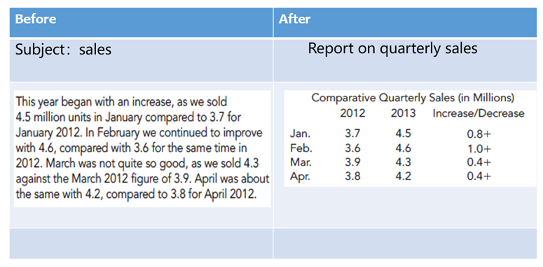

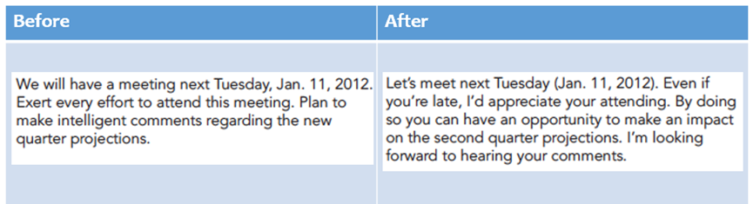

1. **Linguistic features.**

↓Before↓

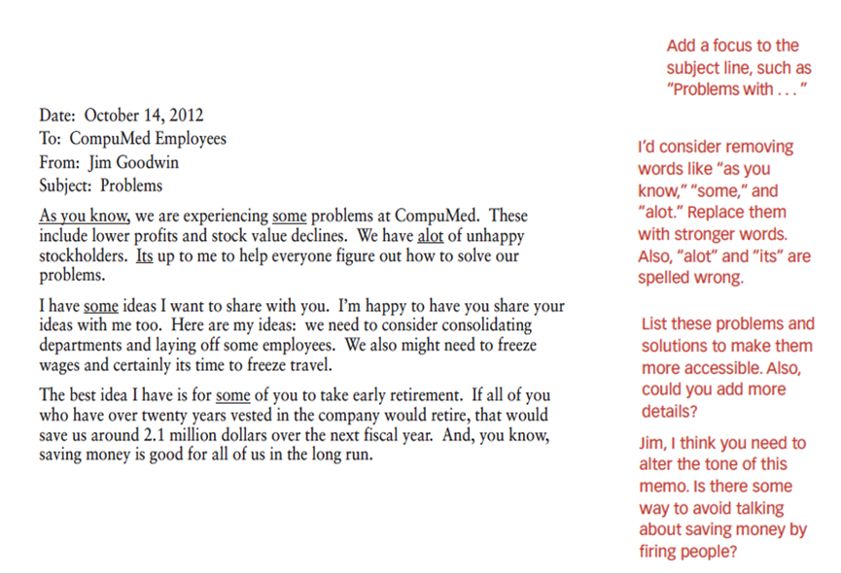

↓After↓

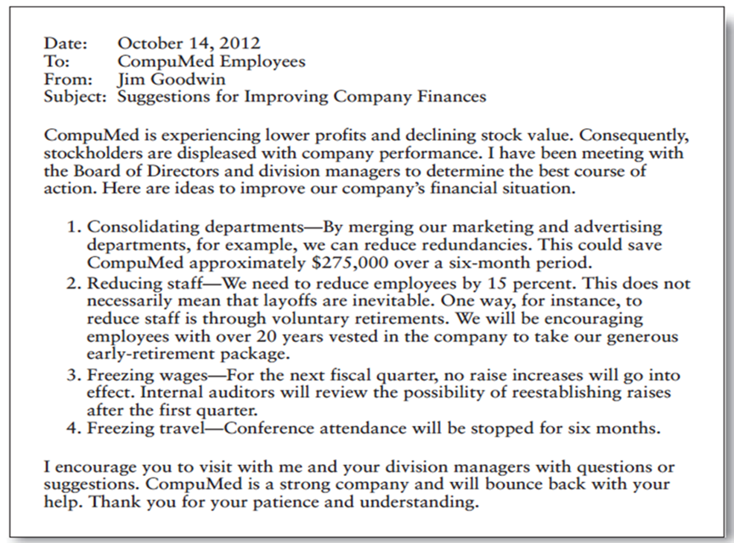

↓Example↓

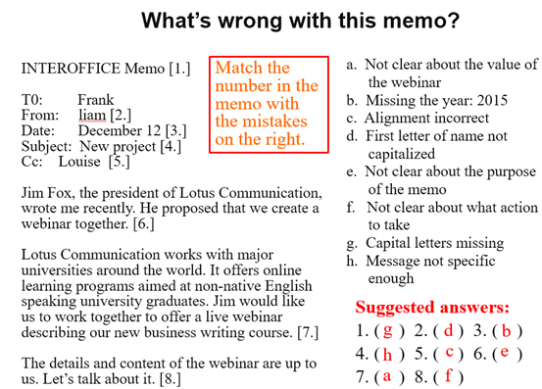

**Unit4 Job application**

1. **Background knowledge of a resume.**

* A resume is a collection of personal information and a summary of your qualifications in the form of a list or table.
* Often used along with the application.
* Generally limited to ONE page (or TWO if you have a great deal of experience).
* Your resume itemizes the qualifications that you can summarize in your application letter.
* The information in your resume is key to helping employees decide whether to contact you for a personal interview.
* It can also serve as the source for specific questions asked during an interview.

1. **Type, components, format of a resume.**

**Types of Resume**

Reverse Chronological resume (traditional): The chronological resume emphasizes education and work experience and is most effective when such experience clearly relates to the job we are seeking.

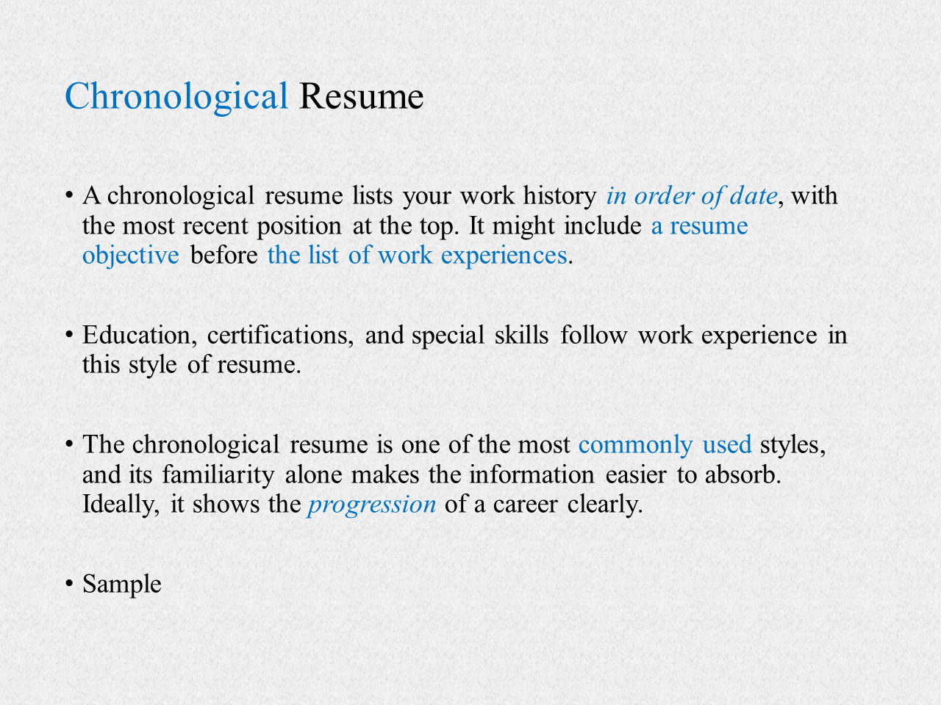

Functional resume (untraditional): The functional resume features the skills that the candidate has got (organizer, researcher, manager, etc.). It provides examples of the most significant experiences that demonstrate these abilities.

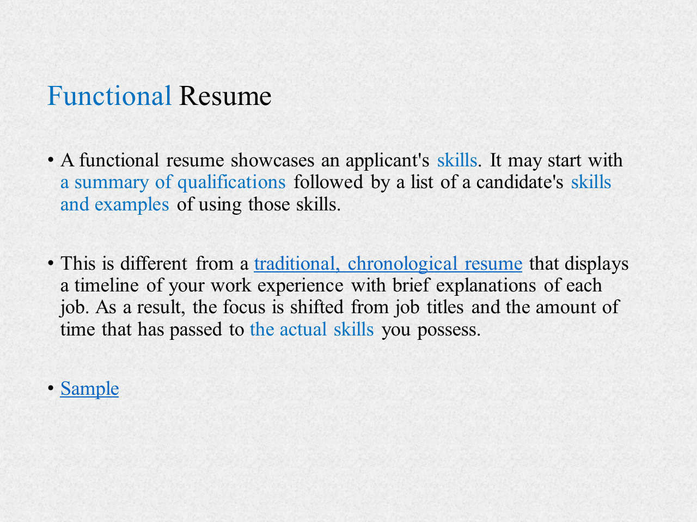

Hybrid/Combination resume: A combination resume includes the best features of the chronological and functional resumes. (maybe too long and repetitive).

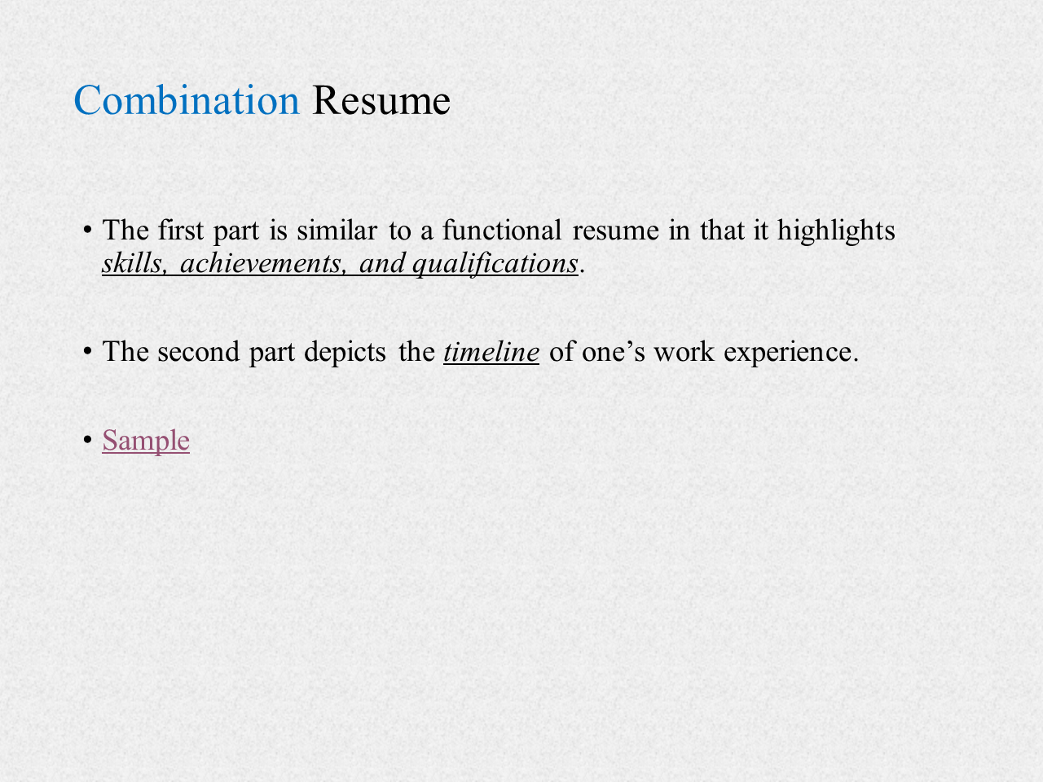

**Components of Resume**

* Identification: name, address, telephone number, email address, etc.
* Objective (optional): Concise and specific, state your desired job or field, and what you hope to accomplish in that field.
* Profile: A summary of your skills, experiences, and goals written specifically.
* Education: Include the degrees you have received in reverse chronological order, include the name of each institution, location and your date of graduation.
* Experience: work experience in reverse chronological order.
* Skills (Optional)

1. **Difference between a resume and a CV.**

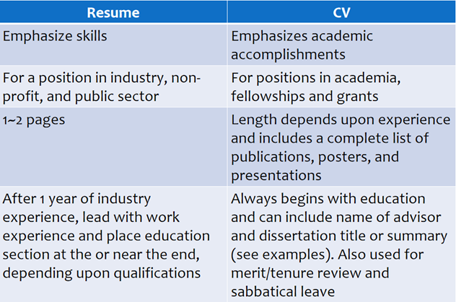

The main differences between the two are the **length**, **purpose** and **format**.

A **CV** is longer, summarizes your entire career chronologically, and doesn't change very often (except when new education or experience is achieved).

A **resume** is shorter, usually just 1 or 2 pages, can be tailored to suit the applicant, and highlights only the skills and achievements related to the job you are applying for.

1. **Writing skills.**

**Starting with power verbs.**

Adjectives tend to be empty and dry in meaning without sufficient and proper support of evidence. So for writing resumes, do not overuse adjectives. Verbs have variations that can improve the effect of résumés writing.

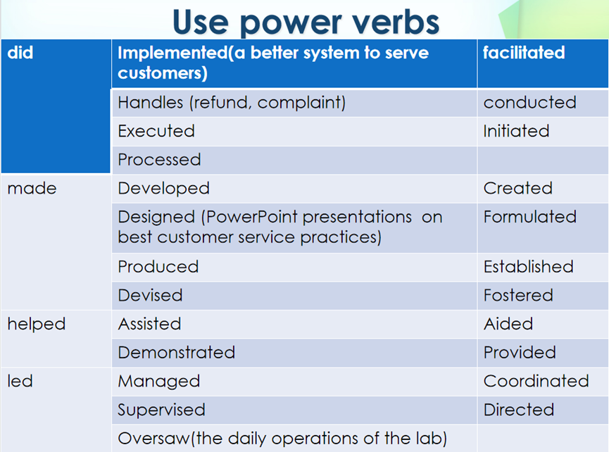

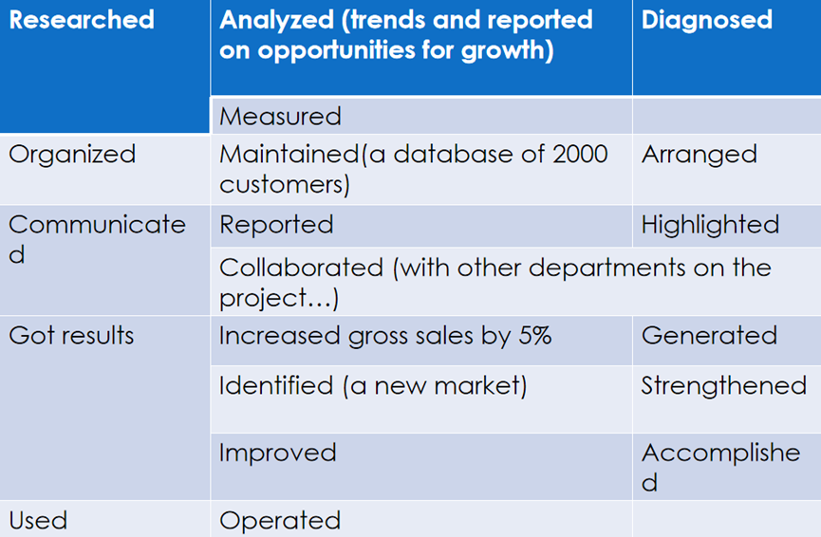

**Achievement writing skills.**

Learn to quantify your achievement in a resume.

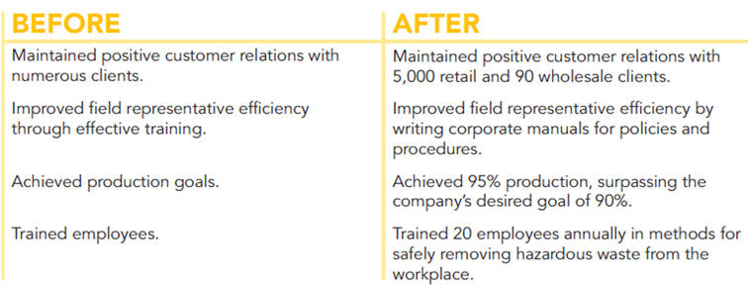

**Cover letter writing skills.**

This is a sales letter in which you market your skills, abilities, and knowledge as they pertain to the position in which you are applying.

4 paragraph pattern:

* The Introductory Paragraph
* The Education Paragraph
* The Employment Paragraph
* The Concluding Paragraph

Sample of the introductory paragraph:

I am writing in response to your notice in the online May 13 New York Times. I would like to be considered for the position in system programming. I hope you find that my studies in computer science at Southeast University, along with my programming experience at Airborne Instruments, qualify me for the position.

Sample of the education paragraph:

(Example About a Project Based on a Course Assignment)

At Southeast University, I have taken a wide range of science courses, but my most advanced work has been in chemistry. In one laboratory course, I developed a new aseptic brewing(酿造)technique that lowered the risk of infection by more than 40 percent. This new technique was the subject of an article in the Southeast Science Digest. Representatives from three national breweries(酿酒厂) have visited our laboratory to discuss the technique with me.

Sample of the concluding paragraph:

(Mentioning your resume or CV; Contacts; request for an interview)

The enclosed resume provides more information about my education and experience. Could we meet at your convenience to discuss the skills and experience I could bring to Pentamax? You can leave a message for me anytime at (303) 555-5957 or wangdongnan@seu.edu.cn.

1. **Ways to improve the appearance.**

A resume should reflect the professional image that we want to create.

It should be:

* Neat and error-free with no whiteouts or hand corrections.
* Legible and well-spaced.
* Printed on good quality paper of A4 size.
* Reproduced clearly on a high-quality printer or copy machine.

1. **Linguistic features.**

Example: Rewrite career objective.

*Seeking employment in a business environment offering an opportunity for professional growth.*

**Confusion**:

1. What kind of business?
2. What kind of opportunities for professional growth?

**Comments**: It has no focus and it is too general.

**Revision**:

*To market financial planning programs and provide financial counseling to ensure positive client relations.*

**Comments**: The revised version does not only specifies which job the applicant is seeking but also how they will benefit the company.

**Unit1 Presentation skills**

Poster sessions, parallel Sessions (Simultaneous Sessions), General Assembly, Plenary Sessions.

**What is an academic presentation?**

* A prepared and formal talk given by a speaker in public.
* A clear and structured way to transmit messages within a time limit.

**Principles for a good presentation**:

* ABC Principle: Accuracy, Brevity, Clarity.
* Seven C Principle: Concreteness, Consideration, Conciseness, Clarity, Completeness, Courtesy, Correctness.
* LST Principle: Look, Smile, Talk.
* KISS Principle: Keep It Simple and Stupid.

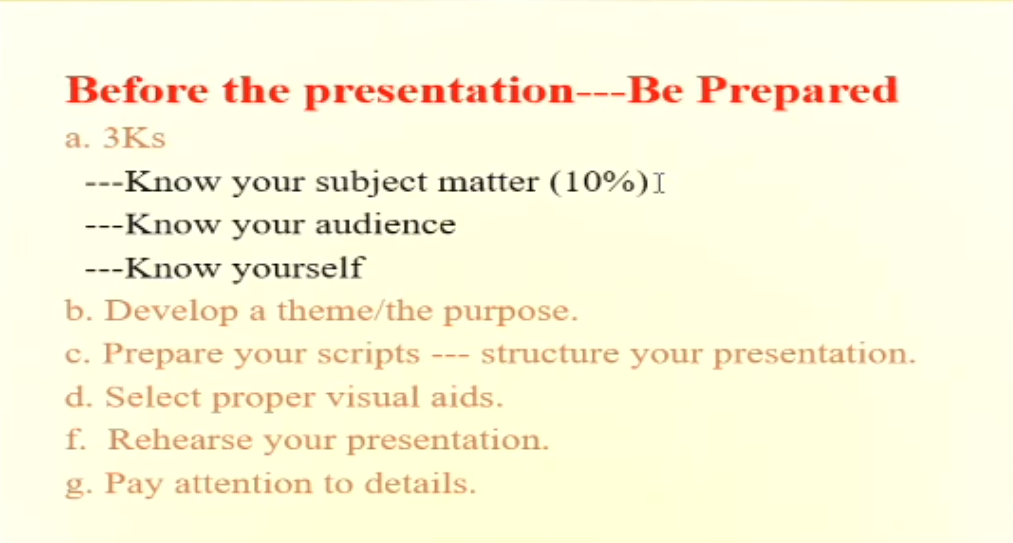

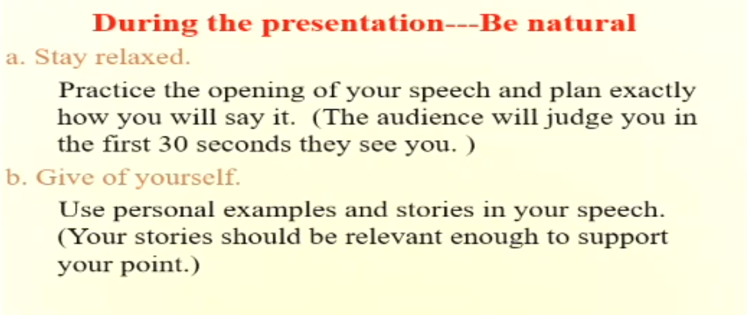

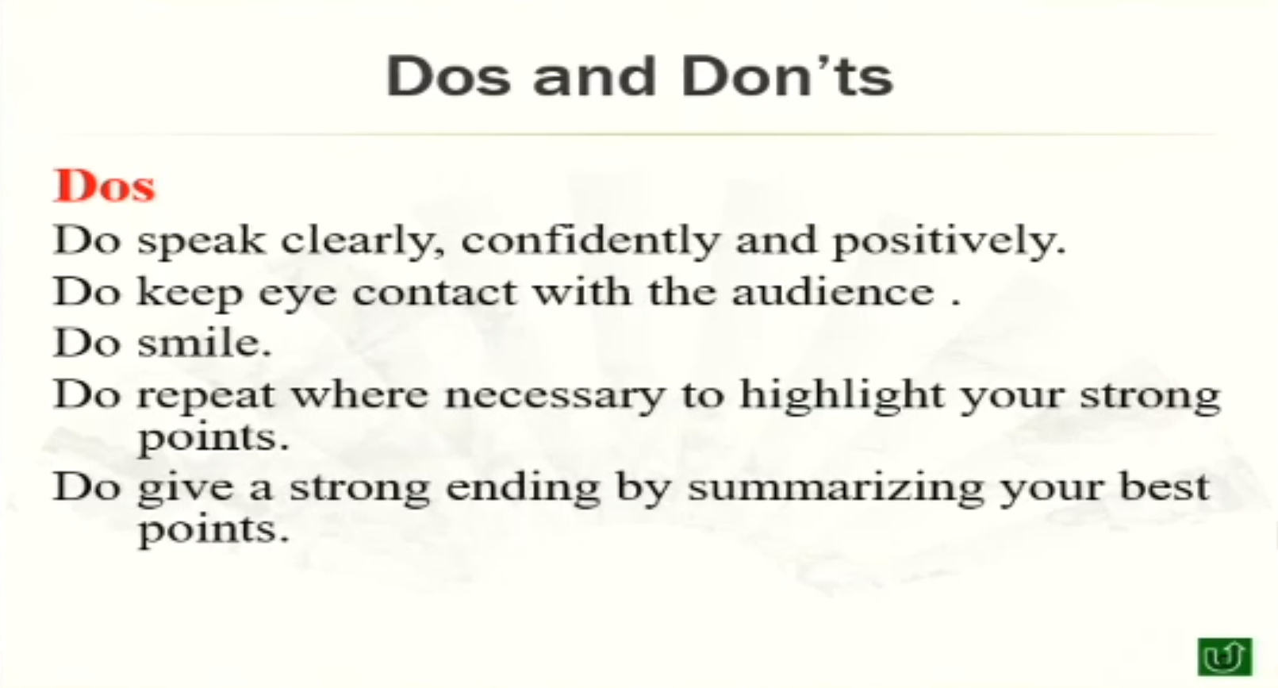

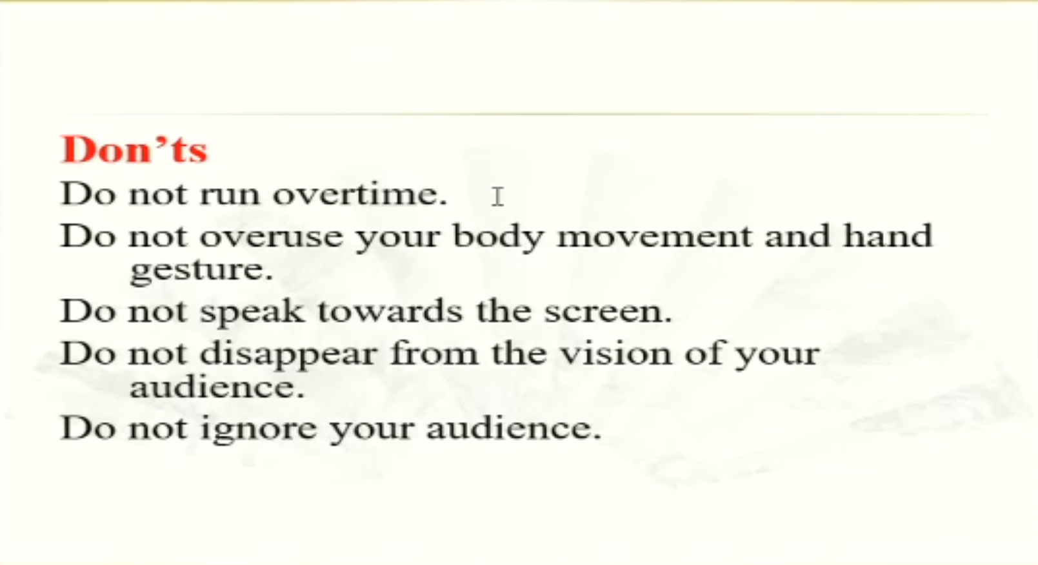

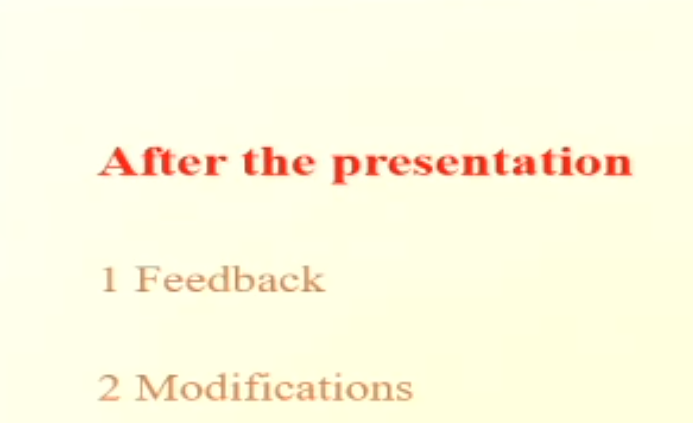

1. **Advantages and disadvantages of visual aids.**

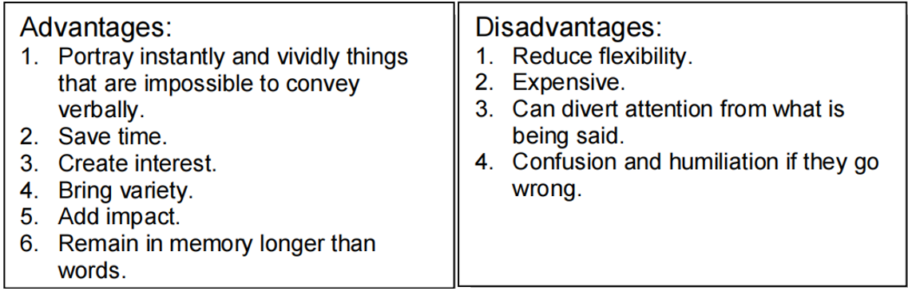

1. **Good ways to open a presentation.**

* Anecdote: Far safer than a joke. A well chosen (it must be relevant) anecdote will help to relax both you and the audience. It can help you to appear more human as a speaker and get the audience on your side. They can help build empathy and rapport.
* Shock Opening: This type of opening can really make an audience sit up and take notice, but make sure you can carry it off confidently. If you have any doubts opt for a safer more conventional opening.
* Historical: Relating your presentation to some relevant historical fact eg '15 years ago this company consisted of 2 men and a very old and unreliable press. Today it is a thriving organisation employing 270 people and with a turnover of 43 million pounds.'
* Quotation: A very neat way to open and close a presentation. Beware of using hackneyed quotations though!
* Current Affairs: Referring to some relevant news item can be a good way to start as there will be commonality with the audience.
* Quesion: Direct questions addressed to the audience helps to get them involved. Rhetorical questions are a powerful way to make your audience think.
* Statement/Statistic: Avoid using too many or the effect will be lost. One or two carefully chosen ones combine the shock element with brevity.
* Comparisons: Well-chosen comparisons can be very dramatic and are especially good it they relate to the audience's experience.

1. **Good ways to end a presentation.**

* The end of the presentation is rather like the opening because this is usually where you will *have maximum concentration from the audience*. It is surprising how an audience wakes up when they hear phrases like: 'Before we stop for coffee' and 'In conclusion!'.
* Your audience should expect the end so *do signpost the conclusion* so that you have maximum attention.
* Remember *the last few words* said by the speaker are what tends to stay with the audience so *make* them *memorable*.
* *Use* some of the *suggested ways for opening your presentation* when you close your talk as well eg. anecdote, quotation, etc.
* Do *come to a definite close* so that the audience knows you have finished speaking. *Avoid simply* saying 'I thank you' and *sliding off the platform*.
* *Hold your position* at the end of the presentation. *Do not* appear to *be in a rush* to leave *as this will affect your credibility* rating with the audience.
* Avoid losing energy at the end of the presentation. *Always practice* the closing sentence to ensure it is delivered *with enthusiasm and energy*. *Do not fall into the trap of the 'That's it' end*.
* Think of *the close of the presentation* as being the 'Take Home message' - the thought that *your audience will take away with them*.

1. **Techniques for handling questions.**

* Put yourself in the positions of the audience.
* Treat all questions with the same importance.
* Never make a questioner feel embarrassed.
* Listen to the question carefully and patiently.
* Pause - give yourself valuable thinking time.
* Show Understanding - seek point for agreement initially.
* Control your audience with eye contact. Keep eye contact with them
* Be honest and flexible.
* Admit the truth that you may be unable to answer for now.
* Always show interest (commit yourself to answering the question at a given time).
* Brevity - keep your answer short and succinct.

1. **Functions of body language.**

**Key words**:

* Posture
* Personal space
* Attitude
* Eye contact
* Audience awareness

**Body Language**

A whole science has grown up around the study of body language. Some research indicates that body language accounts for approximately 65% of human interaction - with words accounting for the rest.

90% of the impression that we make when we first appear before an audience is formulated with the first 60 seconds. It is therefore vital to get not only the words right but also the gestures and Body Language.

Body language can also cancel or reinforce what we are saying verbally and it is essential that the two sets of messages agree.

**Eye Contact**

Eye contact is one of the most important aspects of body language. Eyes are the 'window to the soul' and they will inform the speaker whether their message is being truly received and understood.

It is important to maintain firm and assertive eye contact with your audience. There is nothing more disturbing than a speaker who steadfastly refuses to look at his audience or who insists on looking permanently at a point over their head. The opposite is equally frustrating - a speaker who selects a member of the audience giving them a long hard stare and refuses to avert his eyes. A happy medium is what we need to strive for where we look at all our audience for approximately 2 seconds each.

When your audience is too big for you to look at each person individually then you will need to practice making 'W' or 'M' movements with your eyes so that all areas of the audience receive eye contact.

Lack of eye contact gives the impression of lacking confidence and general furtiveness.

**Hands and Gesturing**

Avoid any unnecessary hand movements such as pulling your hair, scratching, biting your nails, fiddling with a pen, jangling your loose change. These are all examples of displacement activities which we tend to resort to when we are under stress and which show that we are anxious or uncomfortable.

Keep hands at your side if you are tempted to fidget. Try to only use your hands or arms to emphasize a verbal point with a well-timed gesture - this can be very powerful.

In general, the body should remain open with the avoidance of positions such as: folded arms, clamped together hands and lifted shoulders. These closed positions give the impression of a barrier between yourself and your audience.

Avoid any physical barriers such as flip charts, overhead projectors, lecterns, tables and chairs. Maintain maximum exposure to your audience. Own the space in which you are presenting. It is your territory.

1. **Functions of pitch, pace and pause in a presentation.**

This is about Voice Production.

The quality of a speaker's voice is an important factor in how successful a presentation will be. If the sound of the speaker's voice is dull and uninteresting the audience will switch off and it will be very difficult to get them to switch back on again.

Do not worry if you have an accent (Remember what I said about Napoleon and Lenin?)-accent can add a great deal of natural colour and vitality to a voice and it is also part of your personality. However, it is important to make sure that your voice is clear and that you can be understood if you have a pronounced accent.

When you are speaking, always bear in mind the three 'P's:

**Pitch(音高、音域)**. This simply means the note at which you speak. Just as a musical instrument would be very dull if it was played using two or three notes so is the voice if a speaker has a restricted range.

**Pace(节奏)**. Pace is the rate at which you speak. It is important to vary the rate at which you speak in order to add colour and variety to your voice.

**Pause(停顿).** Pauses are very necessary in speech for a number of reasons and these are:

* Gives the speaker time to think
* Gives the audience time to absorb information
* Makes the speaker appear in control, authoritative and confident
* Useful for dramatic effect

Nervous speakers will often resist the temptation to pause, so try to feel comfortable with the pause and do not feel you have to punctuate the gap with 'umms' and 'errs'.

**Unit2 Welcome/Opening speech**

An opening speech is to mark the opening of an event. It is also called a welcome speech. It usually lasts for 1-2 minutes, but can be longer for grander events. The speaker(s) can be the chair/organizer, experts in the field or high officials.

1. **Elements of a welcome speech and its features.**

* Greeting and appreciation.
* Background of the event.
* Purposes/Questions to be discussed.
* Agenda.
* Good wishes.

1. **Purpose of a welcome speech.**

* Extending welcome and appreciation.
* Setting the tone.
* Informing the attendees of the theme and agenda declaring the opening.
* Declaring the opening.

1. **General linguistic patterns for each purpose in a welcome speech**.

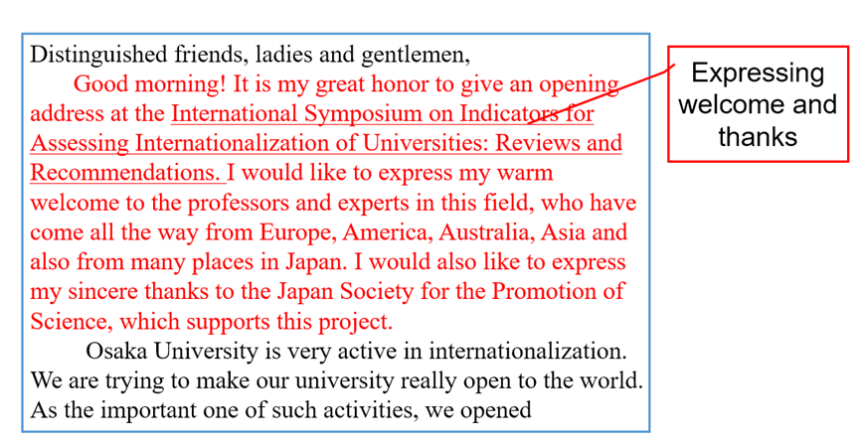

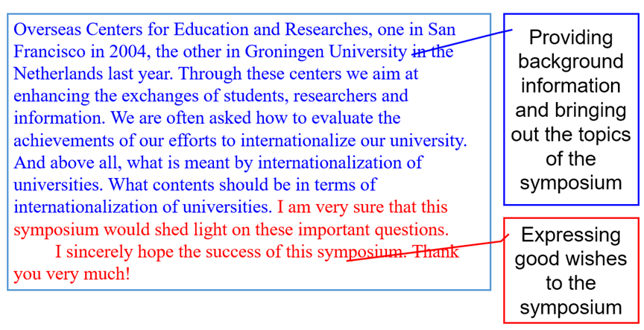

1. **Language: useful expressions.**

**For background**

* The… was founded in … and it has undertaken ….congresses in many countries of the world in over 30 years.
* Last year, the… was successfully held in … and this paved the way for this year’s meeting.
* …. Has experienced its 8 years in China and achieved a great success s in 2003. it has become one of the most important events in China.
* Started in …, this event is the first of its kind and has been wholly supported by…
* For those of you who did not attend the previous conference in this area, I would like to present a brief background on the purpose of this series of meetings.
* There are several reasons for organizing this conference. Research on … is entering a period of mushrooming growth. Therefore, it is highly desirable that interested scientists gather to report new advances, to review processes and to discuss conflicting findings and to make more meaningful plans for the future phases and directions of research.

**For content**

* There are more than 50 interesting symposia, covering a wide range of branches of …
* a wide range of exciting and cutting-edge topics, including … , will be covered in various formats including workshops, speaker session and poster sessions.
* The meeting will tackle the key questions of… as well as …
* Topics to be presented include…

**For purposes**

* We hope you will be enriched, stimulated, and greatly enjoy an excellent program that highlights…
* I sincerely hope that participants worldwide will take the opportunity to exchange ideas, to enhance collaboration, to establish friendship for the future and to promote our capacity of …
* The purpose of … is to provide a platform for…, to meet, to exchange ideas, and to establish professional networks. It is a forum to focus on specific disciplinary research as well as multi-disciplinary research.
* The conference aims to showcase the progress of…, to promote global collaboration and to cultivate a new generation of scientists.

**For good wishes**

* I wish the congress will be successful and productive, and wish you to have a pleasant m and memorable experience in …
* I hope that you will have a scientifically and socially productive experience in …
* I wish that … will be another successful and fruitful event.
* I wish every success for this conference. I will all the participants enjoy their visit to…
* I would like to conclude my speech by wishing the conference a complete success.
* Please accept my best wishes for a rewarding and successful conference.
* We are confident that you will enjoy the science, the friendship, and rich cultural activities here in ...

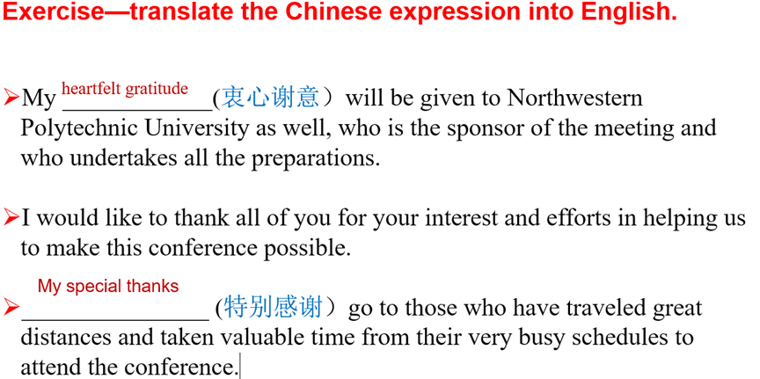

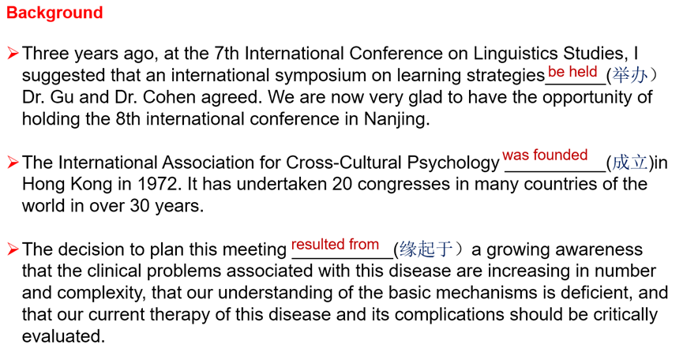

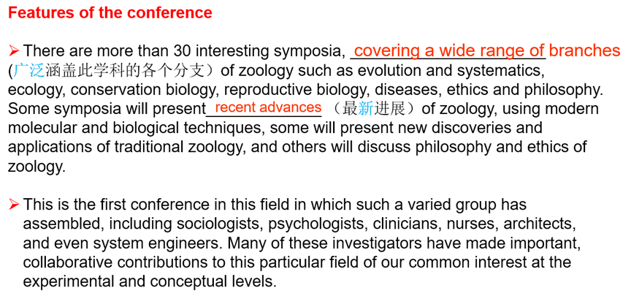

**Unit3 Introducing speakers**

1. **How to make preparation for speaker introduction.**

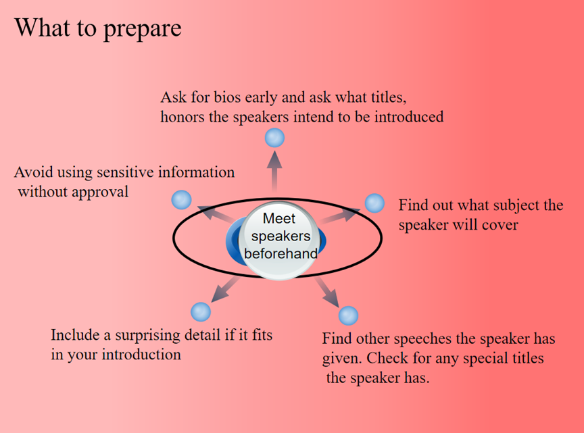

Think: Why this speaker, on this subject, to this audience?

* Name.
* Affiliation and titles.
* Research interest, current research records.
* Books and publications.
* Awards.
* Topic or title of the presentation.

1. **Contents of speaker introduction.**

* Self-introduction
* Enthusiasm.
* Slow down & Speak clearly.
* Introduce.
* Orient yourself towards the speaker.
* Shake the speaker's hand.

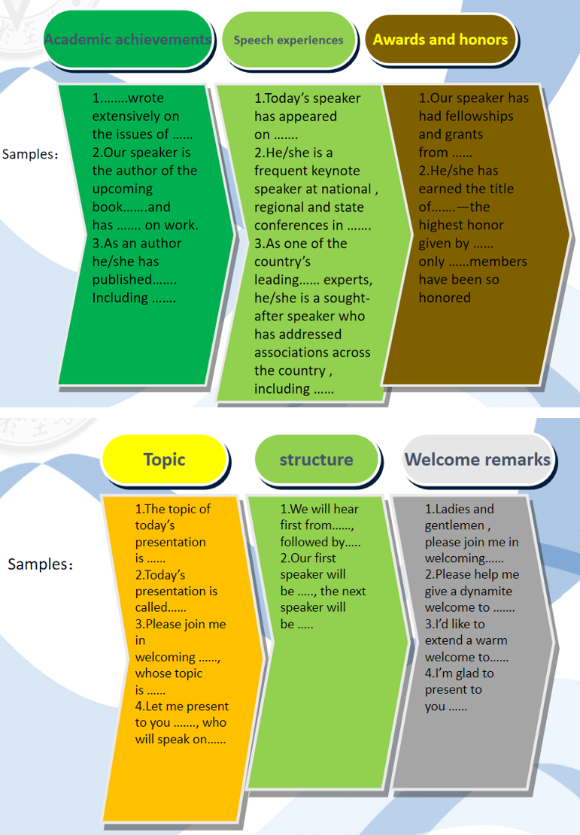

1. **Dos and don'ts in a speaker introduction.**

* Speak loudly and clearly.
* 0.5-2min/200 words.
* Do not read the introduction.
* Smile and be enthusiastic.

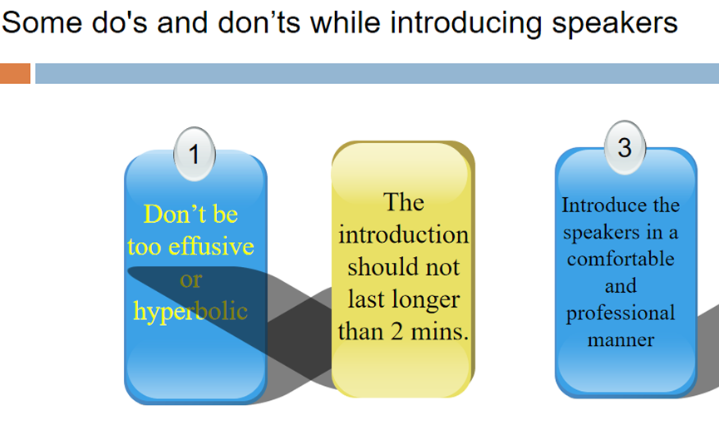

1. **What to do after the introduction.**

Orient yourself towards the speaker, lead the applause and shake the speaker's hand.

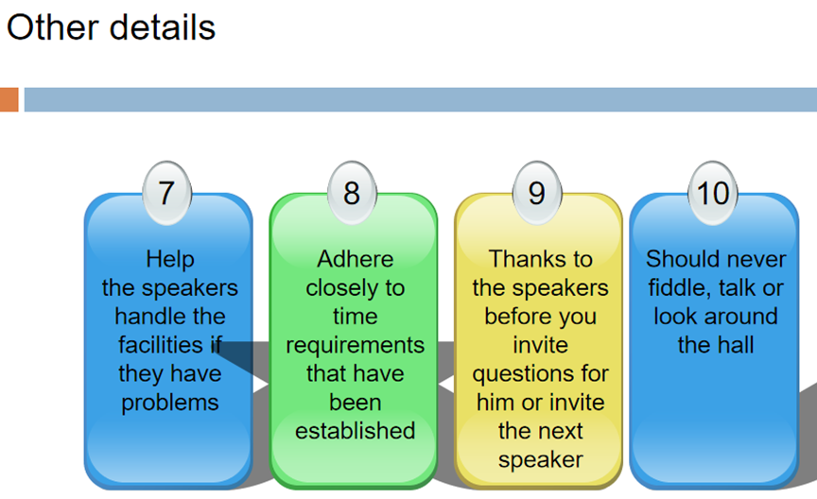

1. **Language: useful expressions.**

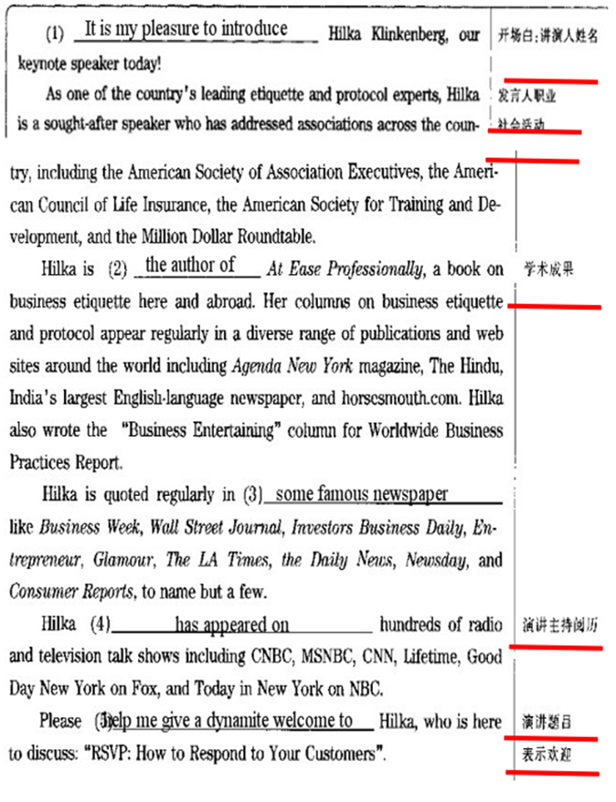

**Unit4 Keynote speech**

1. **Definition of keynote speech.**

* The principal theme in a speech or literary work.
* An address designed to present the issues of primary interest to an assembly (such as a political convention) and often to arouse unity and enthusiasm.
* A speech made to a political gathering that focuses on points that are considered to be currently most important.
* A good keynote speech is inspirational and unifying for its audience.

1. **Definition of keynote Speaker.**

* The person who gives the keynote address at a large meeting.
* Someone who gives the main address at a formal gathering such as a conference.
* Someone who delivers a great and/or important speech, someone who has been designated to give such a speech.

1. **Structure of keynote speech.**

* Introduction：What you are going to tell your audiences.
* Body (main points): The longest and most important part. Two to five main points along with supporting examples. Select them carefully, Phrase them precisely, Arrange them strategically.
* Conclusion: What you have told them.

1. **Organization of the body of the speech.**

The most effective order depends on three things - your topic, your purpose, and your audience.

↓时 空 原 结 度↓

* Chronological Order: Speeches arranged chronologically follow a time pattern. They may narrate a series of events, explain a process or demonstrate how to do something.

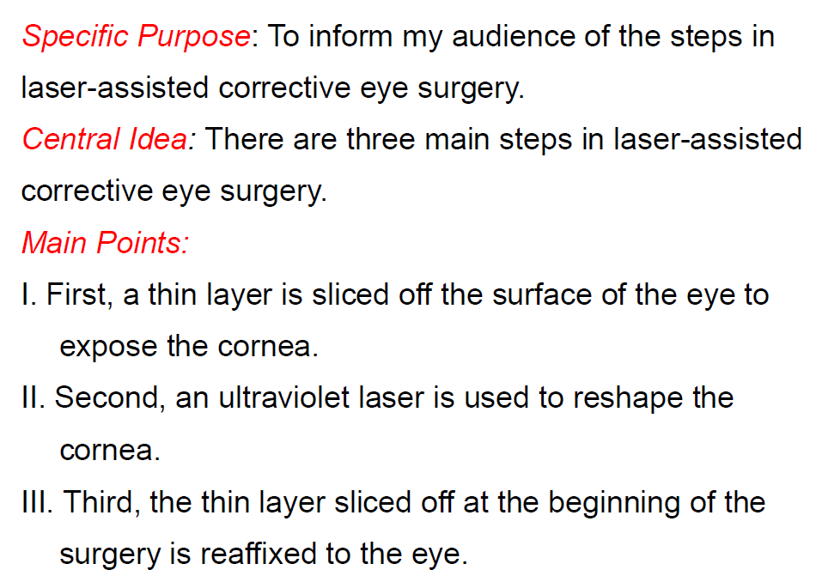

* Spatial Order: Speeches arranged in spatial order follow a directional pattern, i.e. the main points proceed from top to bottom, left to right, east to west, or some other route.

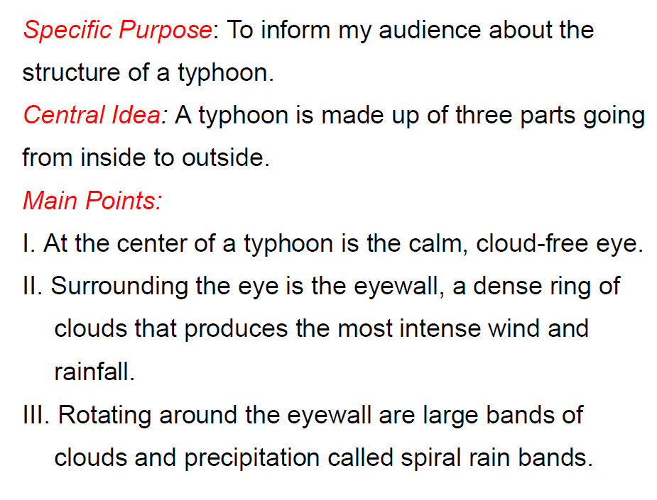

* Causal Order: You can deal first with the effects and then with the causes.

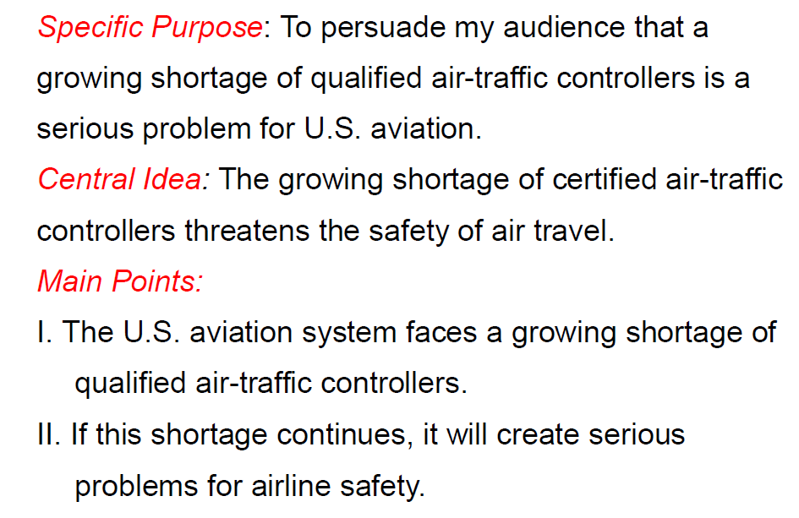

* Problem-Solution Order: Speeches arranged in problem-solution order are divided into two main parts - the existence and seriousness of a problem and a workable solution to the problem.

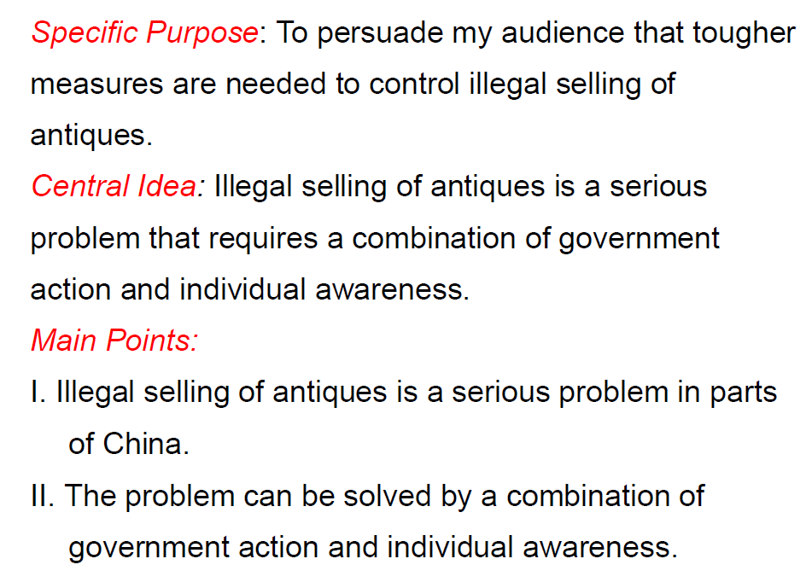

* Topical Order: The speech topic is divided into subtopics, each of which becomes a main point in the speech.

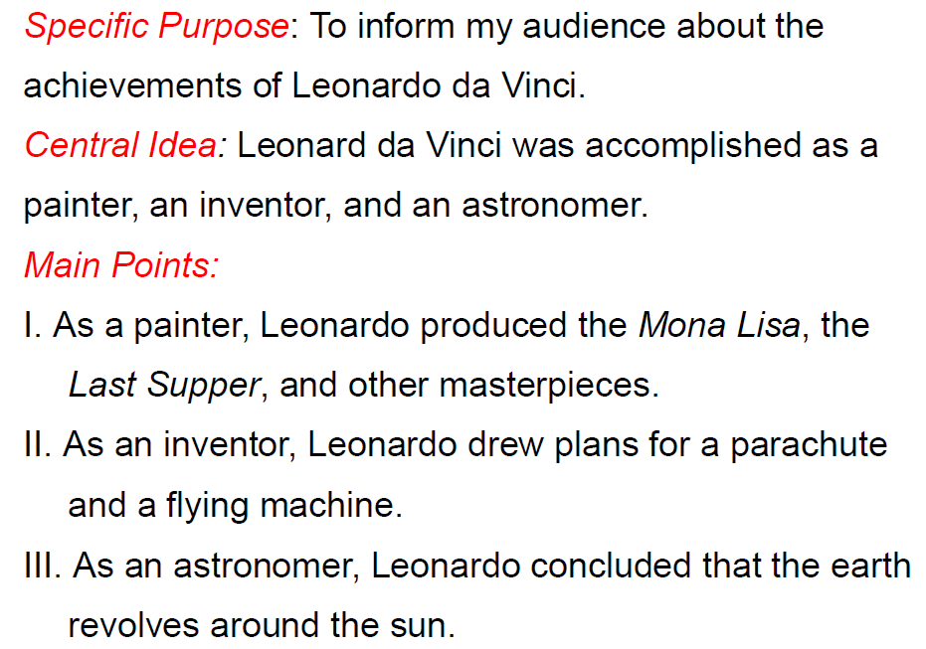

1. **Techniques of delivering a keynote speech.**

* Limit the Number of Main Points：In most cases, a speech will contain two to five main points.
* Keep Main Points Separate: Each main point in a speech should be clearly independent of the others.
* Try to Use the Same Pattern of Wording for Main Points: The main points should follow a consistent pattern of wording so as to be easier understand and remember.
* Balance the Amount of Time Devoted to Main Points: Sufficient time is allowed to develop each main point so that all the main points receive enough emphasis to be clear and convincing.

1. **Language: useful expressions.**

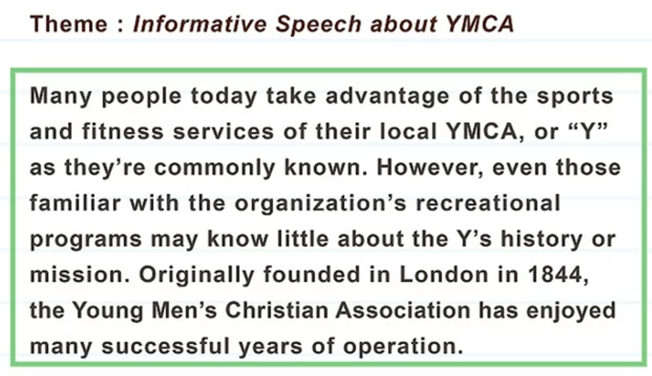

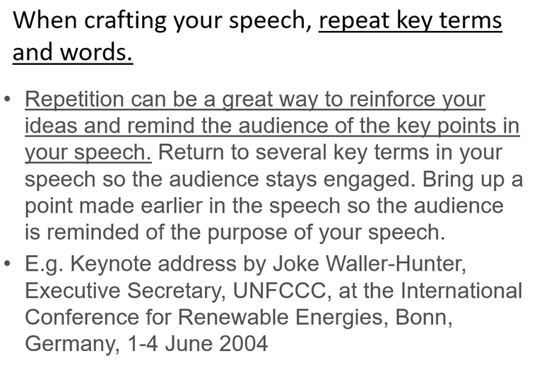

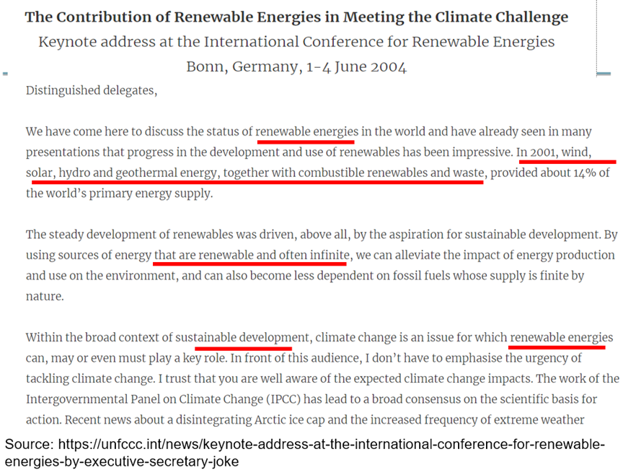

**Unit5 Q & A**

1. **The time for the Q & A Session.**

It starts the moment the keynote speaker finishes his/her speech.

If there are several keynote speakers, it's very like that the Q & A session happens after all the speeches are over.

1. **Announcing the Q & A Session.**

Who announces the time?

* The chairperson, who gives the audience the timetable or the agenda before the conference actually starts.
* The keynote speaker.

Both should tell the audience how long this session will last.

1. **Timing the Q &A Session.**

No matter who is in charge of this session, the chairperson or the speaker, he or she should control the time, especially at the last one or two minutes. For example, we have only two minutes left, one more question.

Example1：

Chairperson：

Well everyone, I'm sure you'd like to join me in thanking Michael for what was a really inspirational presentation. Sincere thanks Michael. Now, I'm sure many of you will be keen to ask some questions, so I'd like to open up a Q & A session. Please raise your hand if you have any questions at all. Janice, go ahead.

Example2:

Speaker:

Thank you very much. And I look forward now to taking some questions from all of you.

1. **Possible question types.**

* Ask the speaker to further elaborate on a particular concept.
* Ask the speaker to repeat the point you failed to understand.
* Any questions centering around the topic the speaker has made.
* Follow up another listener's question.
* Air your own opinion different from the speaker's.
* Ask the speaker to give you some suggestions on your professional development.

1. **Tips for answering questions.**

**How to respond?**

* Regarding positive questions, go ahead directly.
* Regarding negative, challenging or even provoking questions, stay calm and show your appreciation to the listener's question before you make comments.
* Regarding the questions beyond you, just be honest.

**Don'ts**:

* Do not raise a question without permission/a microphone.
* Do not speak, both speaker and listener, until the whole audiences are quiet.
* Do not introduce yourself too much.
* Do not ask more than two questions at a time. Leave opportunities to others.
* Do not forget to say "Thank you" at the end of your speech, either speaker or listener.

1. **Language: useful expressions.**
2. That's a very good/interesting/inspiring question.
3. Well Janice, first of all, thanks for a very good question. I think you have hit the nail on the head actually.
4. Thanks for your good question, but I think your question is too complicated to answer here. Should we meet and discuss it face to face after the conference?
5. I'm sorry, this question is quite beyond my reach, to be honest.
6. Frankly speaking, I have little knowledge on that topic. Sorry.

**Unit6 Closing speech**

1. **Functions of a closing speech.**

The role of a conclusion in a speech is to signal to the audience that the speech is coming to a close and help them remember the most important points from the speech.

1. Thanking all related persons and organizations.
2. Commenting on the contributions of the conference.
3. Noticing the arrangement for next conference.
4. Declaring the conference close.

* Expressing Thanks.
* Summarizing the Achievements.
* Announcing the Next Conference.
* Announcing the Closing of the Conference.
* Expressing Good Wishes.

1. **Elements of a closing speech.**

* Appreciation.
* Summary.
* Evaluation.
* Expectation.
* Invitation.
* Closing.

1. **Similarity and difference between an opening speech and a closing speech.**

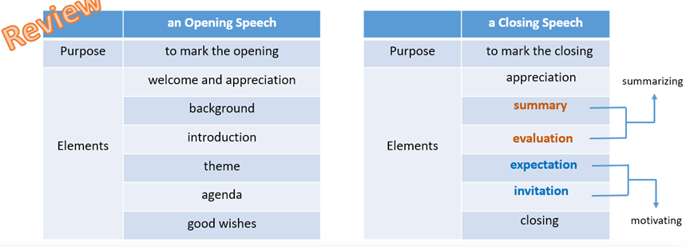

1. **Linguistic features of a closing speech.**
2. **Language: useful expressions.**